Wesley Fegan
Professor Vaish
YWCC 307
28 March 2022

Project Team 10

Topic 5: Your team is involved in designing a new cryptocurrency for a sovereign client. You have been asked to evaluate Ethereum as a contender of bitcoin for the basis of your currency. What does your team think and would suggest as your team’s choice to your client?

Deliverable: Research the cost of hardware, electricity, and expected profit.

Cost of hardware:

The basic hardware required is a chassis and motherboard supporting multiple graphics cards, as well as a power supply strong enough to support the hardware.

Graphics cards will be treated separately as they are one of the most important factors that determine job throughput.

The basic components can be bought separately or all together. Prices can vary widely depending on the quality of parts. A multiple GPU motherboard can be as cheap as ~$60 or as expensive as >$1000.

A seller on AliExpress sells the “B85” chassis which includes a motherboard, a 2000 Watt power supply, ram, a processor, as well a CPU. The system can accommodate up to 8 graphics cards. The cost is just $355 for one unit; a %2 discount applies on order of 2 or more units. The only setback is that the shipping cost is $242.31.
https://www.aliexpress.com/item/1005003593023289.html

There are far too many permutations of this base hardware to make a comprehensive analysis of their cost. The chassis type used will also depend on the client’s needs. Both Ethereum and Bitcoin can be mined using GPUs so the base hardware is less relevant when comparing the two.

I will also warn against the use of so-called Ant Miners or other dedicated ASIC based hardware. They have a much higher upfront cost than GPU mining and use a considerable amount of electricity. Ant Miners can only mine Bitcoin and currencies using a similar algorithm, which means that if Bitcoin loses popularity the miners cannot be resold to recover investment. Should the client choose to implement their own currency using the same algorithm as Bitcoin, they will have to wait for firmware support for their currency. In the beginning, it will make much more sense for the client to focus on general use hardware.

As stated earlier, one of the most important factors determining throughput is the graphics card used. The following variables will need to be taken into consideration: the cost of the card, currency generated per day, and its electricity usage.

As of the 28th of March 2022:
1 BTC = $47,651.20 USD
1 ETH = $3,382.29 USD

We will ignore the cost of the base hardware and consider an initial unit investment of $10,000 USD towards graphics cards.

All values are in US dollars.
The currency generated per day was taken from minerstat.com and kryptex.org.

The energy cost was determined by using the current average commercial energy rate in New Jersey: $0.12.

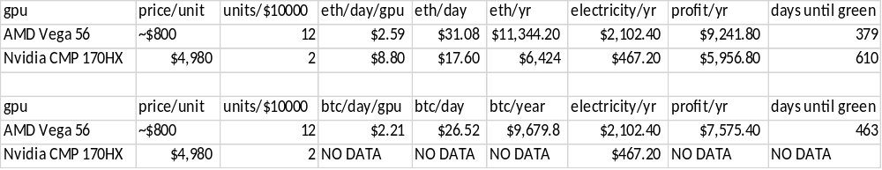
There are a few key takeaways in this data.
- Many weaker cards use more electricity, but generate more profit than few more-powerful cards.
- Ethereum is more profitable than Bitcoin.
- Interest is waning in Bitcoin.

The Nvidia CMP 170HX, despite being released last year, and being crypto-oriented, hasn’t been widely used for Bitcoin.
It has however been used for Ethereum and most of the crypto-related mining stats posted are in respect to Ethereum.

The truth is that Bitcoin is a limited asset. There can only be a certain amount of Bitcoin created. This is intended to protect it from inflation. The issue here is that as more Bitcoin are mined, the harder it is to solve the remaining blocks. The result is that stronger hardware is needed and less money can be made.
https://www.investopedia.com/articles/forex/051115/bitcoin-mining-still-profitable.asp

Ethereum on the other hand does not have a hard limit in the number of coins that can be created. The only limitation is that 18 million coins can be created per year. This means that Ethereum is much more feasible than Bitcoin to mine and has room for growth.
https://www.investopedia.com/news/why-ethereum-cofounder-proposing-hard-cap/

Based on my research, I would recommend basing the new currency on Bitcoin.

